­

Final Report

Sports Club

WEBSITE DESIGN

INTERNET PROGRAMMING LANGUAGE

(CSE 326)

### By

|  |  |  |  |  |  |
| --- | --- | --- | --- | --- | --- |
| Sr. No. | Registration No | Name of Students | Roll No | Marks Obtained | Signature |
| 1 | 11901734 |  | B-46 |  |  |
| 2 | 11901772 | Prince Kumar | B-47 |  |  |
| 3 | 11901784 | Harsh Raj Singh | B-48 |  |  |

### **Submitted To Pooja Rana, Assistant Professor**

Lovely Professional University Jalandhar, Punjab, India.

**Acknowledgemen**

**I would like to express my special thanks of gratitude to my teacher of Internet Programming Language Pooja Rana, as well as our fellow teammates who gave their best for the opportunity to do this wonderful project of website designing on the topic of the sports club, which also helped us in doing a lot of research and we came to know about so many new things, we learned and explore many things we are thankful to our teacher Pooja Rana.**

**Secondly, we would also like to thank my parents and friends who helped me a lot in finalizing this project within the limited time frame and helped in their hectic schedule.**

**Table of Content(all files are in html format)**

1. **Index**
2. **Gallery**
3. **About-Us**
4. **Sports pages:**

* **Rugby**

**-Teams**

**-Gallery**

**-About-Us**

* **Cricket**

**-Teams**

**-Gallery**

**-About-Us**

* **Boxing**

**-Teams**

**-Gallery**

**-About-Us**

* **Basket Ball**

**-Teams**

**-Gallery**

**-About-Us**

* **Volley Ball**

**-Teams**

**-Gallery**

**-About-Us**

* **Swimming**

**-Teams**

**-Gallery**

**-About-Us**

Sport || Home

Boxing

Swimming

Volleyball

Basketball

Cricket

Rugby

Homepage

Team name

Team name

Team name

Home

About us

Gallery

Login

**Screenshoots of pages**

**Index.html** 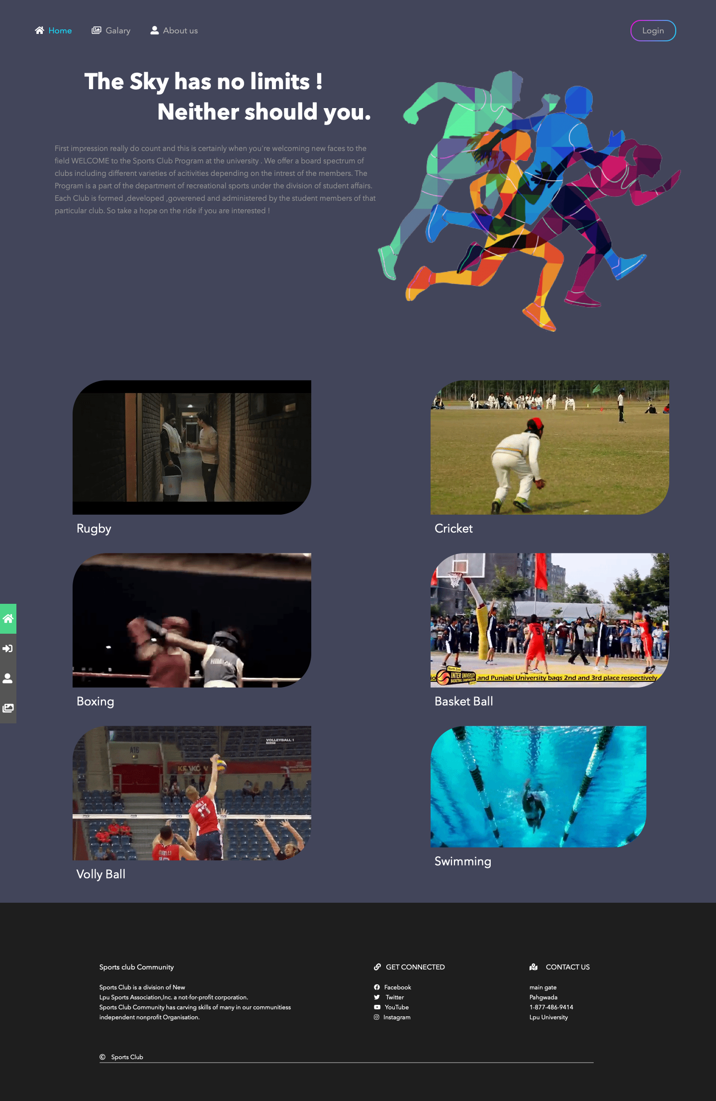

**Gallery.html**

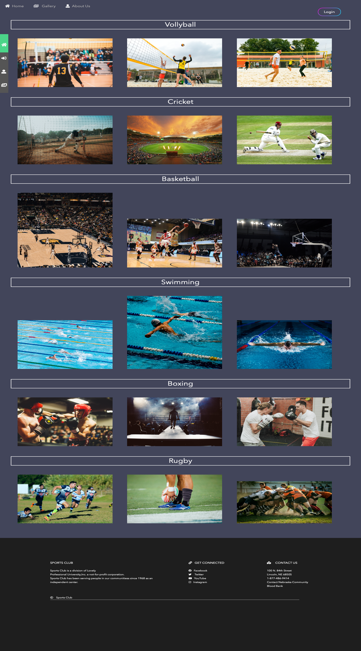

**About-Us.html**

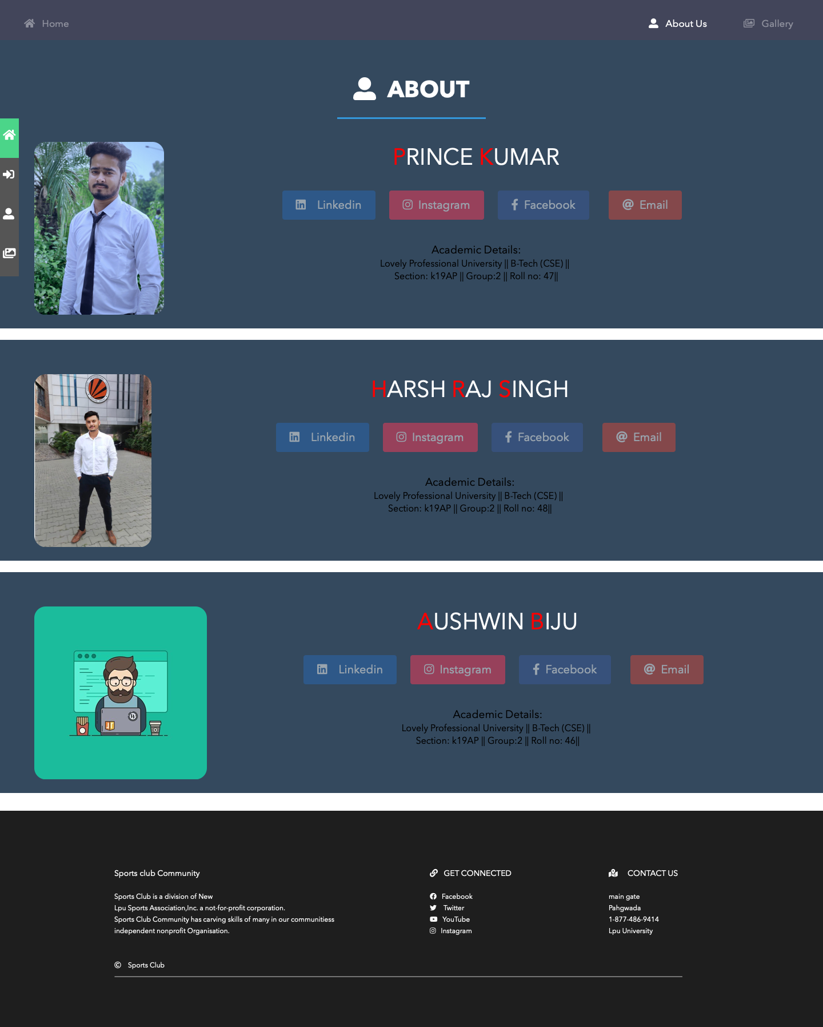

**Sports pages:**

**1.Rugby.html**

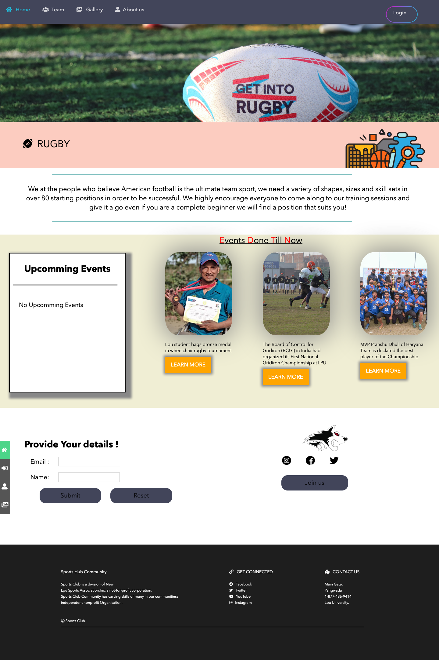

**Rugby-team.html**

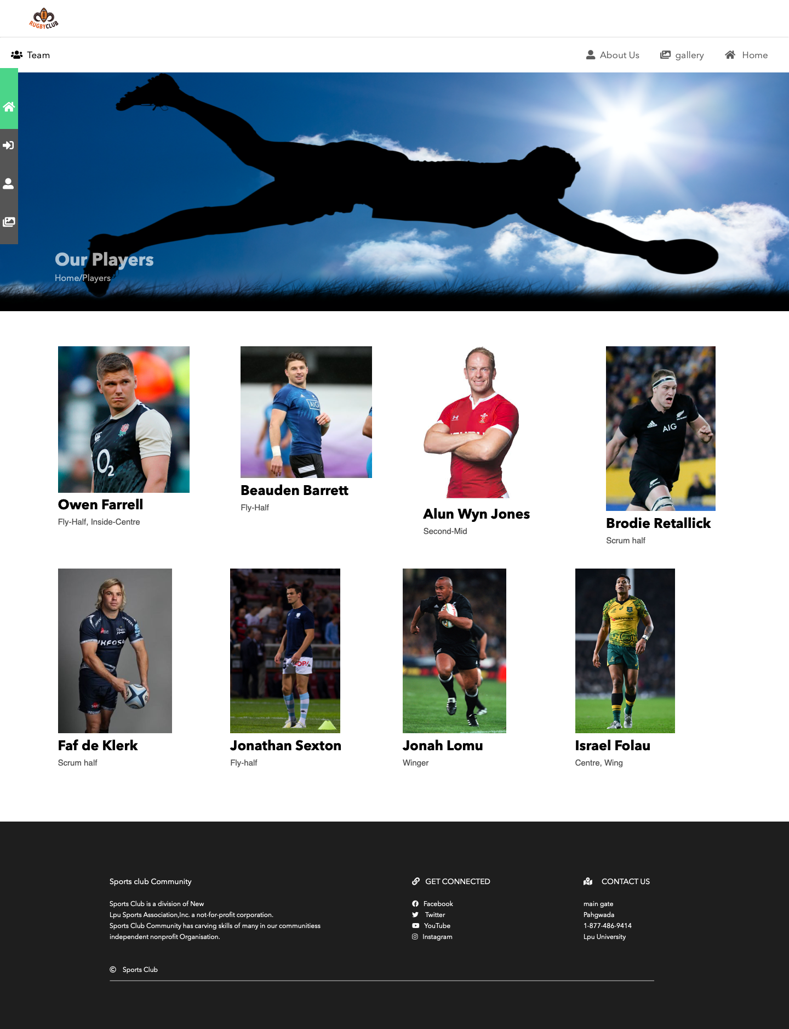

**Cricket.html**

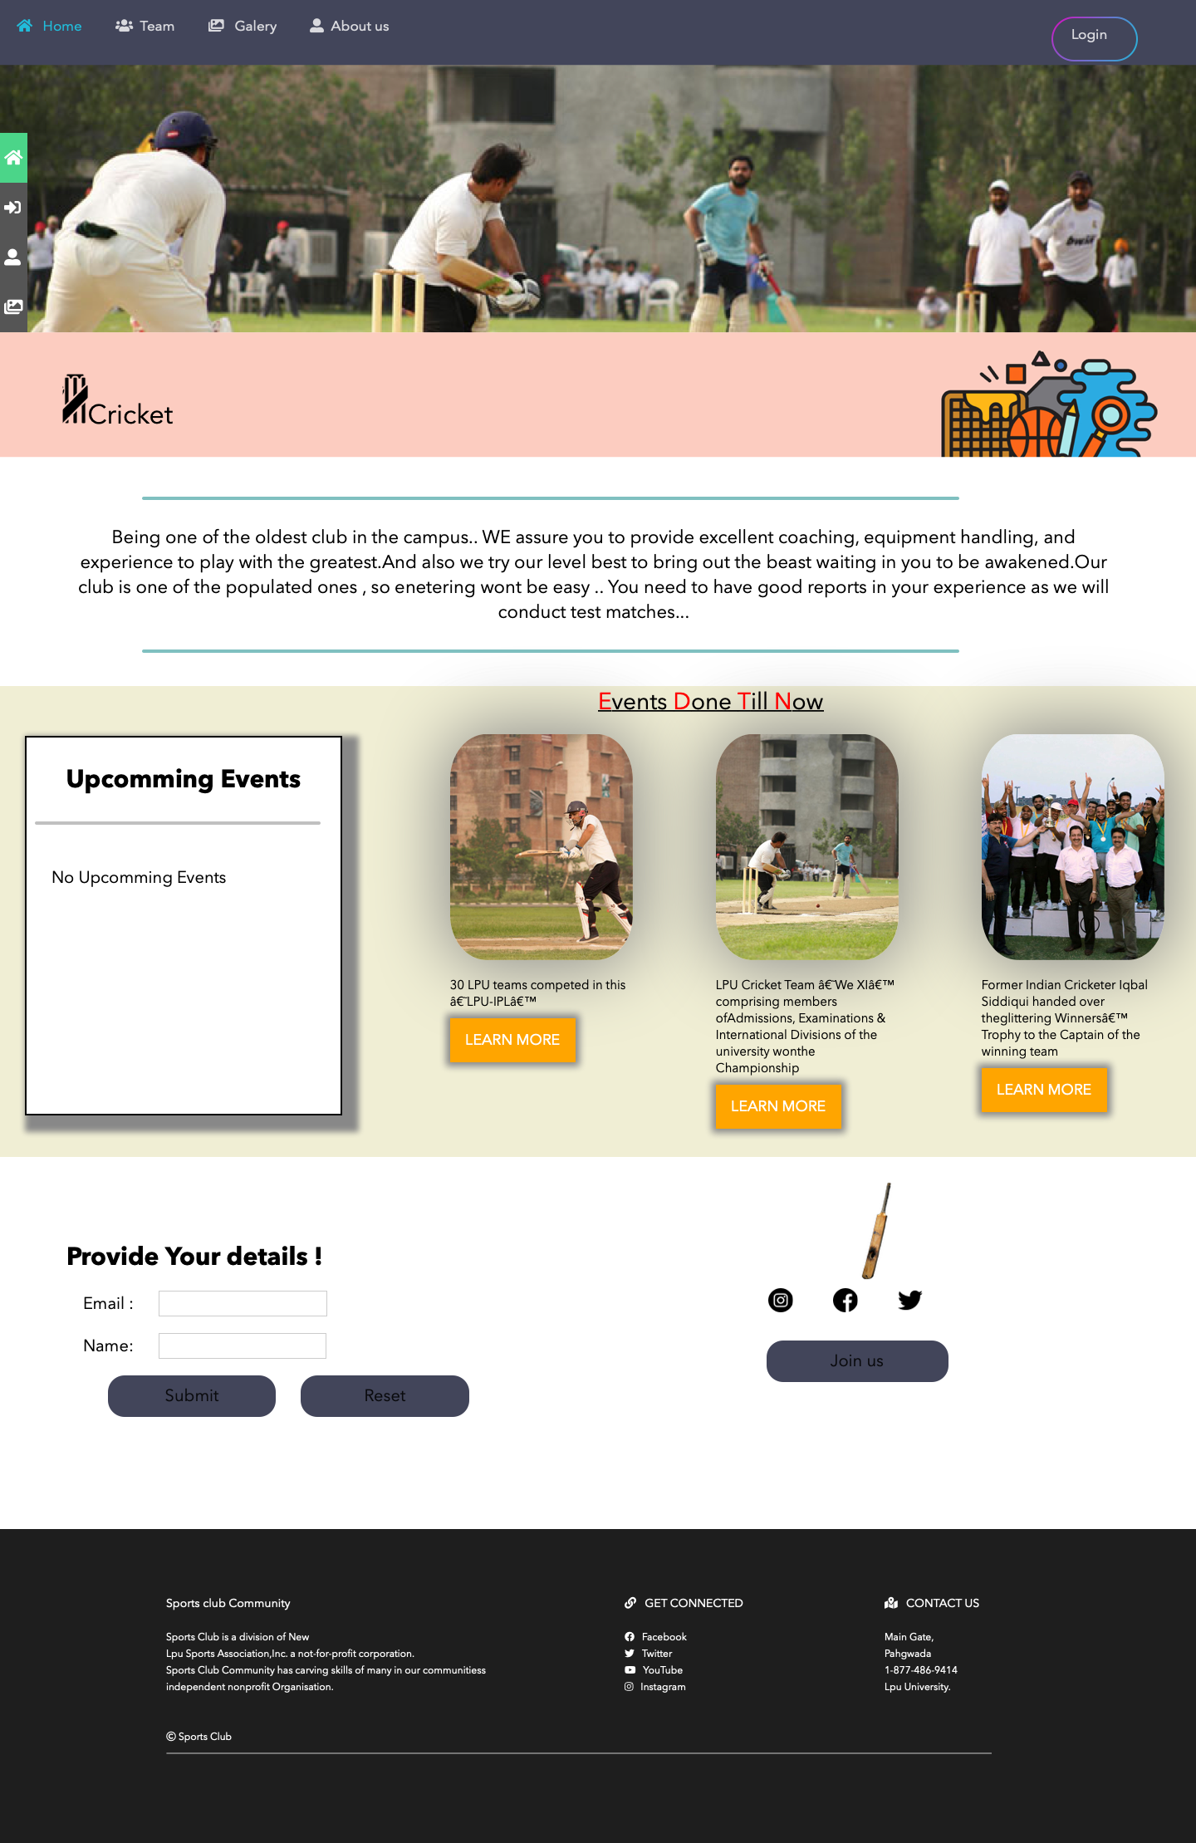

**Basketball.html**

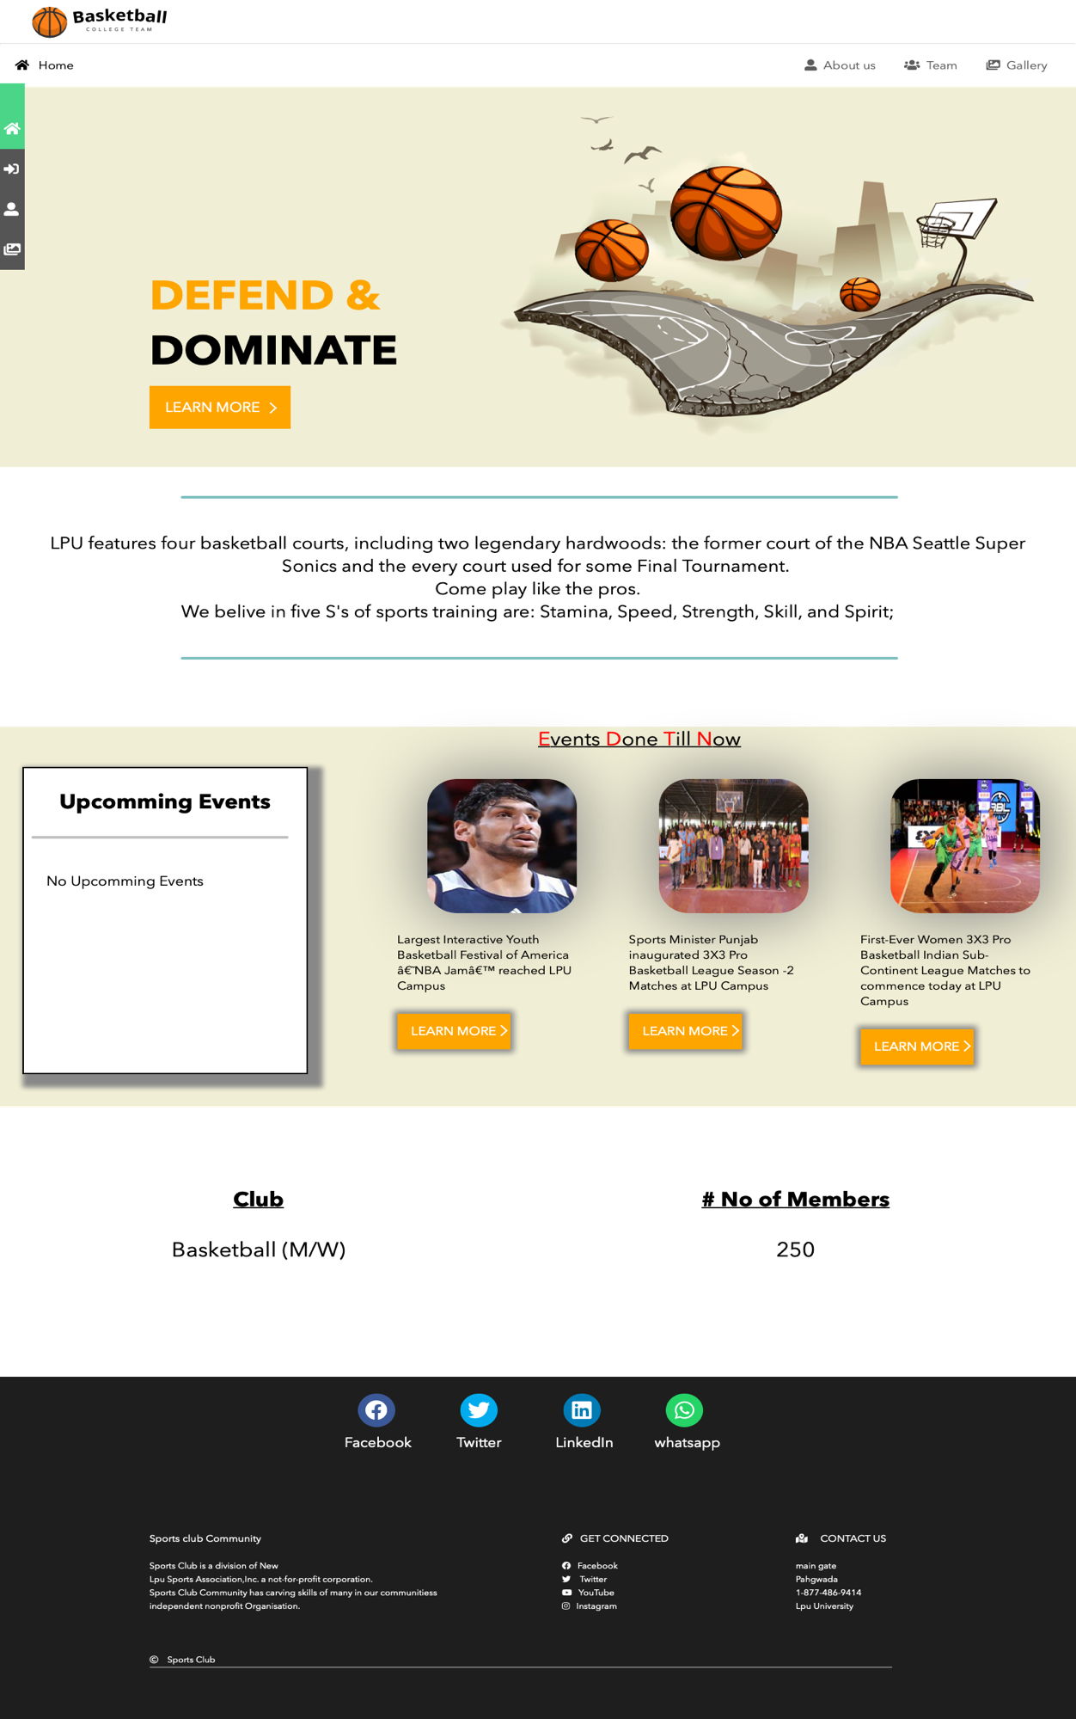

**Baskteball-teams.html**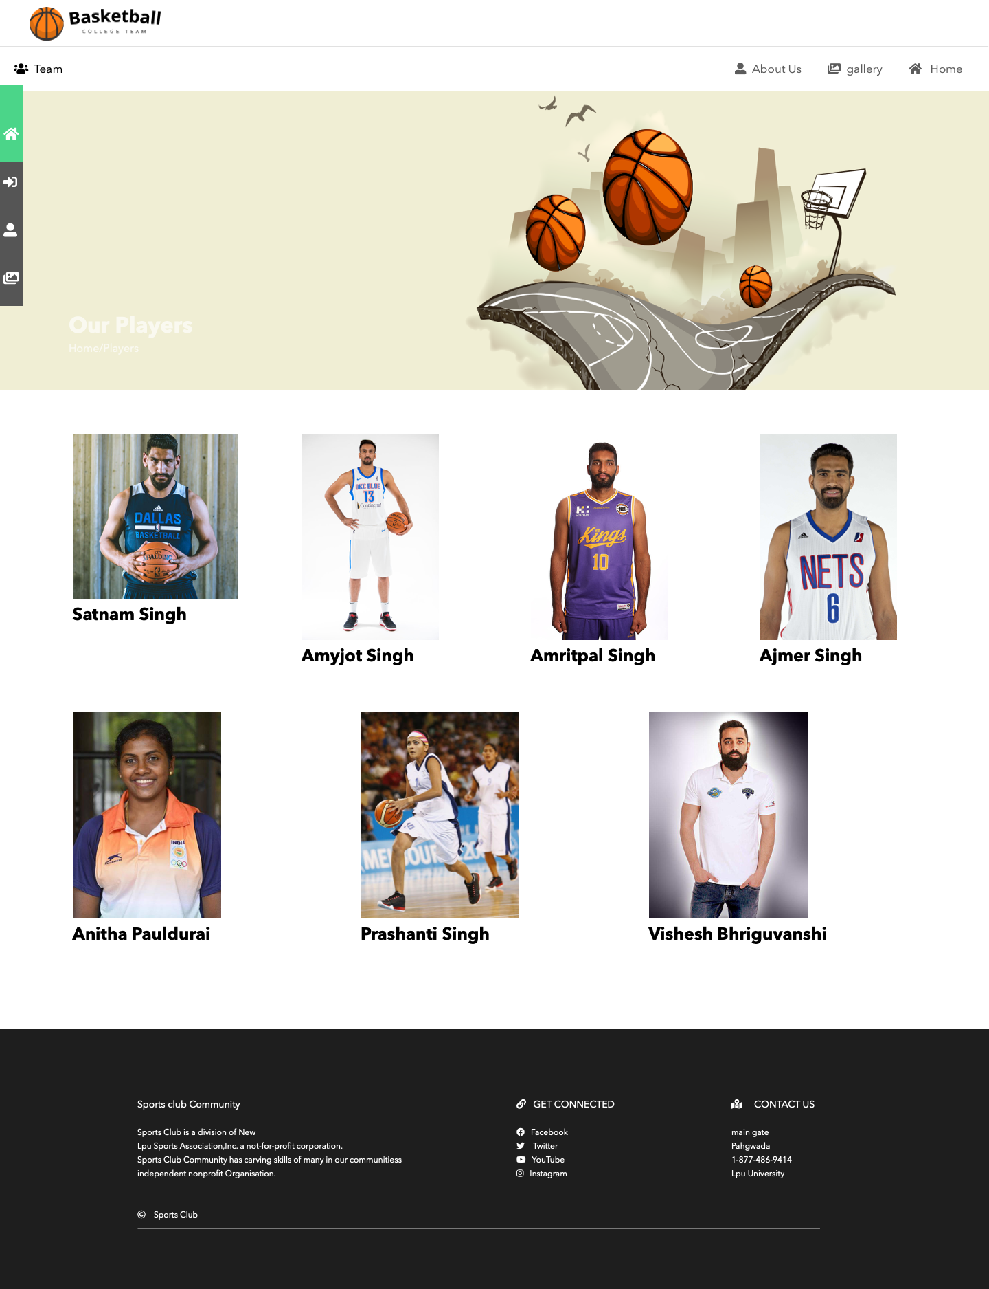

**Bibliography :**

* **Youtube**
* **Google**
* **W3schools**
* **Geekforgeek**
* **Unspalash (for images )**
* **Books**
* **Html(by tutorials point)**
* **Css(by tutorials point)**
* **Javascript(w3schools)**